- The Monetary Policy Committee has stated that underlying inflationary pressures would need to continue to cool before policy is loosened. So evidence that UK pay growth remains stubbornly high and the labour market may be tighter than originally thought, reinforces our view that the committee is likely to take a cautious approach to rate cuts.
- Elsewhere, December's fall in GDP and downward revisions to the three previous months meant GDP fell for a second successive quarter in Q4 2023. December's drop was partly due to the apparent collapse in retail sales that month. But January's subsequent rebound will offer a decent boost to Q1 and we think the ingredients are in place for a steady pickup in activity this year.
With the Office of National Statistics publishing four top tier economic releases, this week offered a wealth of data for Bank of England policymakers to digest as they consider the pace and timing of future interest rate cuts.
The first of those, Tuesday's labour market release, was consistent with the Monetary Policy Committee adopting a relatively cautious approach to loosening policy settings. The release saw data from the Labour Force Survey reintroduced after a five-month hiatus. This incorporated the latest estimates of the size and composition of the UK population, but didn't address the major issue of low survey response rates. Still, taking the new LFS data at face value, the labour market looks tighter than it did last summer, with the unemployment rate much lower and economic inactivity significantly higher.
The prospect of a marked slowdown in headline (three-month average of the annual rate) average weekly earnings growth in December was strong given a high reading for bonuses in September would drop out of the calculation. Indeed, total earnings growth fell to 5.8% in December from 6.7% in the previous month. But the cooling in headline private sector regular pay growth, the BoE's preferred measure, was more modest, and it remained above 6%. Our sentiment-based nowcast, developed in collaboration with Penta, suggests that pay growth is likely to remain at similar levels in the first couple of months of 2024 (Chart 1).
Chart 1: Our proprietary wage indicator suggests the slowdown in pay growth has halted
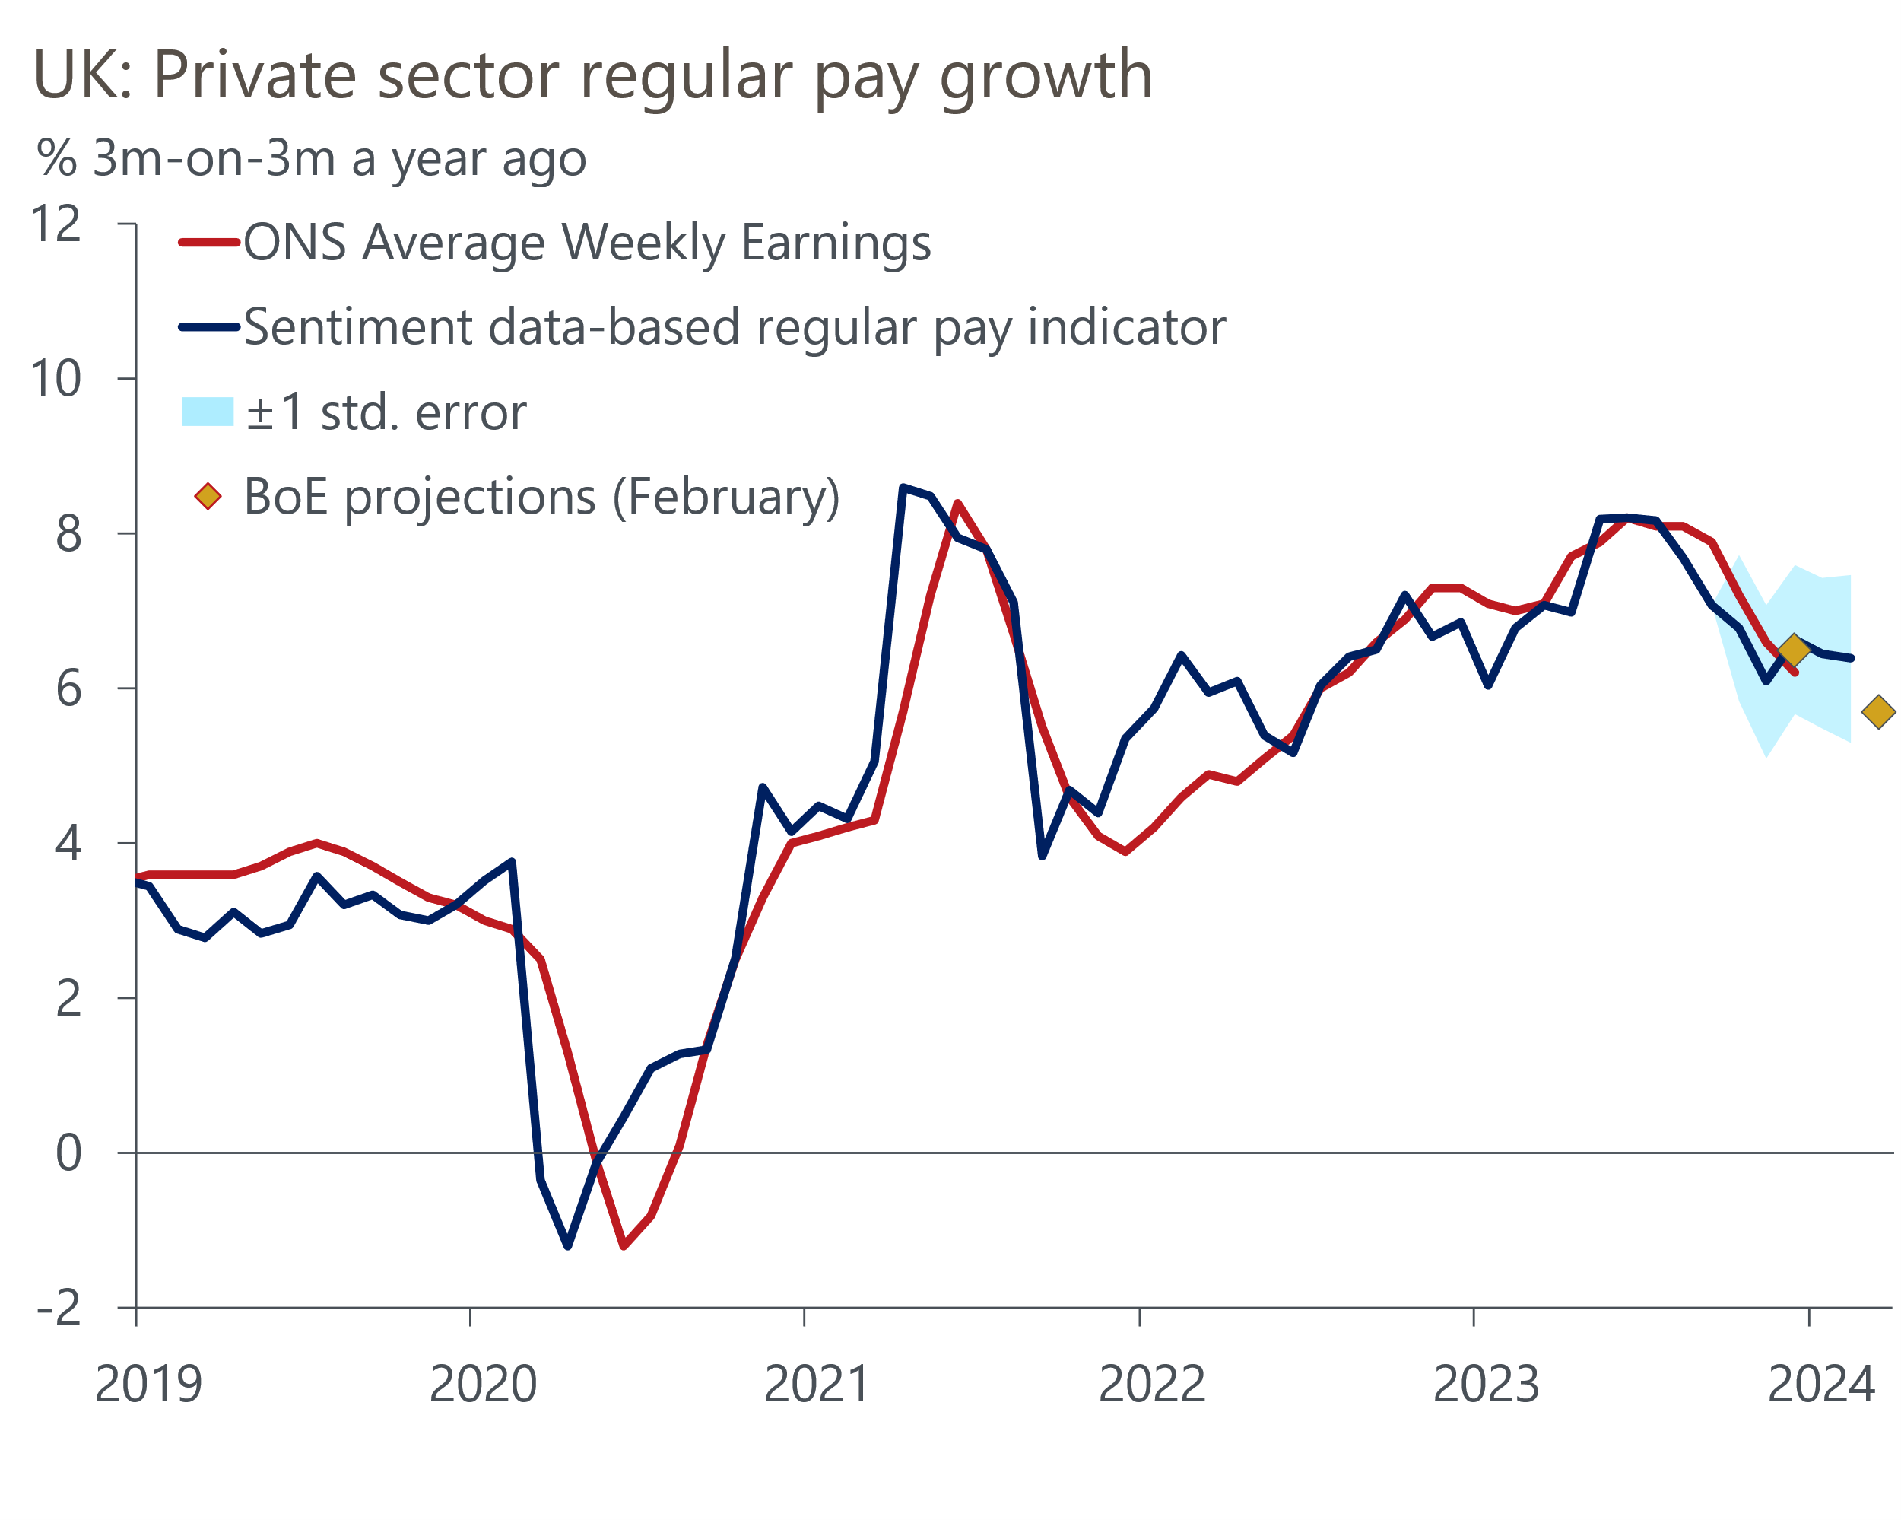
Sources: Oxford Economics, Haver Analytics, Penta

This week's inflation data showed that CPI inflation remained unchanged at 4% in January. Given the strength of base effects caused by the large decline in services prices in January 2023, we had expected headline inflation to rise, but there was a chunky m/m fall in services prices this January too. This was partly because January's usual drop in air fares was amplified by the ONS more than doubling the components' weight in the CPI basket. This drove a lower than expected outturn for core inflation, offsetting the impact of a 5% increase in the Ofgem energy price cap on headline inflation.
The MPC has been clear that evidence on the strength of underlying inflation pressures will determine how quickly policy is loosened. That services inflation was slightly lower than the BoE's latest projection is a small step in the right direction. But with the MPC already expecting inflation to fall sharply in the coming months, and this week's downside surprise largely driven by the combination of movements in erratic categories and ONS CPI weight changes, we don't see this release as a game-changer. So, together with evidence of tighter labour market conditions and stubbornly strong private sector pay growth, this reinforces our view that the MPC will take a cautious approach to the timing and pace of rate cuts.
Growth has not featured highly in the MPC's decision making in recent years. This week's GDP release reported that activity fell 0.1% m/m in December, while the outturns from September to November were revised down (Chart 2). This left output down 0.3% in Q4, a second successive modest quarterly contraction. Looking more broadly, output has been stagnant over the past two years, with the level of GDP in Q4 2023 slightly lower than in Q1 2022.
Chart 2: Consumer-facing services led the decline in activity over H2 2023
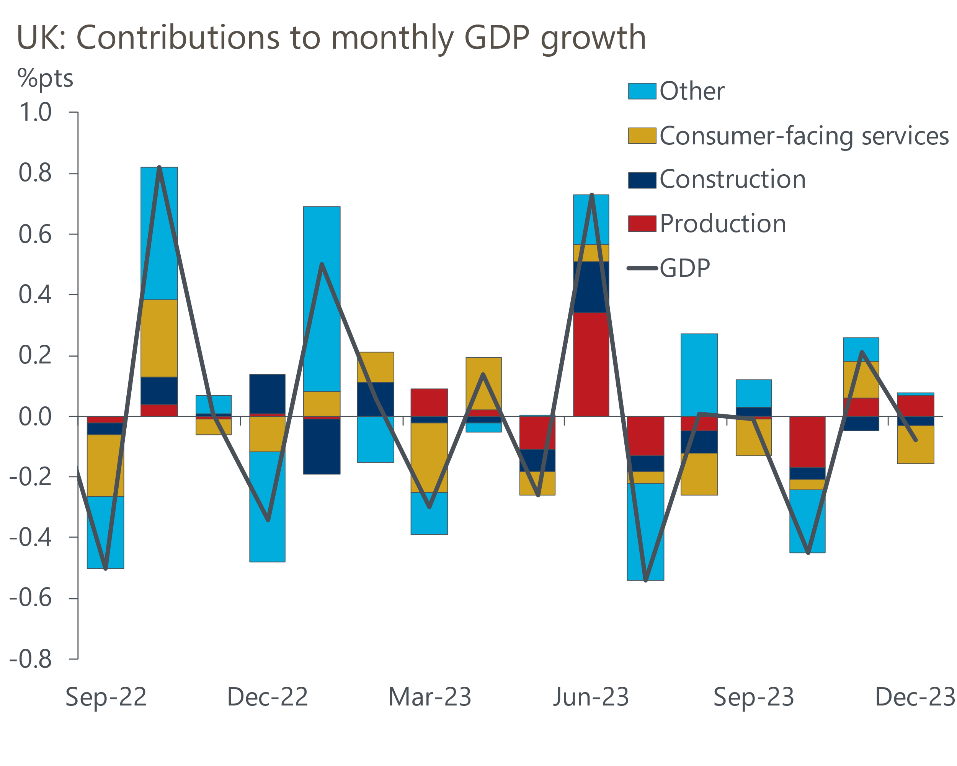
Sources: Oxford Economics, Haver Analytics
But we think Q4 2023 is likely to mark the low point for activity. A key factor underpinning December's weakness was the slump in retail sales. But retail sales volumes rose 3.4% m/m in January, making up all the ground lost in the previous month. As well as demonstrating the caution needed when interpreting what is a very noisy series, this points to a strong rebound in distribution output in the January GDP release. Furthermore, business survey data has been much stronger in early-2024, something that BoE Governor Andrew Bailey referred to this week in remarks at Loughborough University.
More broadly, the ingredients are in place for a better performance this year. Lower inflation means wages are now growing again in real terms, and household spending power should get a further boost from a large fall in energy bills from April. And though households still face powerful headwinds from the lagged effect of past rises in borrowing costs and tightening fiscal policy, we still expect household disposable income to grow at a solid pace this year. This should drive a gradual pickup in GDP growth over the course of 2024. Still, the weaker outturn for Q4 2023 is likely to mean that we cut our forecast for 2024 calendar year GDP growth when we publish our UK Country Economic Forecast next week, due to the scale of the carry-over effects.

The week ahead
A much quieter week is in prospect, beginning with the release of January's public finances data. Owing to the boost from receipts from self-assessed taxes, the public finances tend to be in net surplus in the month of January, and this is likely to be the case again this year. The surplus should rise in y/y terms given that spending was boosted in January 2023 by energy support payments. As a result, we expect public sector net borrowing (excluding banks) was -£15.8bn in January.
Next week, will also see the release of flash S&P Global/CIPS surveys for February. The forward-looking indices in January's survey suggest the gap in sectoral performance may have widened. The services survey reported a rise in new orders and business optimism, on the back of improving business and consumer spending, so we think the flash services PMI will increase to 54.6. In contrast, January's manufacturing survey indicated that supply-chain disruptions are threatening to compound the demand-driven downturn in the survey's output balance. Therefore, combining our expectations of a higher flash services PMI and a more subdued manufacturing output balance points to a composite PMI of around 53.1. Given evidence of further supply-chain disruption would result in longer vendor delivery times, we think this could see the manufacturing PMI rise to 47.2.
Table 1: Week ahead calendar
Date | Events | Period | Measure | Unit | Previous | Forecast
Feb 21 | Public finances | Jan | PSNB ex | £bn | 7.8 | -15.8
Feb 22 | S&P Global/CIPS manufacturing | Feb | PMI | % bal | 47.0 | 47.2
Feb 22 | S&P Global/CIPS services | Feb | PMI | % bal | 54.3 | 54.6
Feb 22 | S&P Global/CIPS composite | Feb | PMI | % bal | 52.9 | 53.1
Source: Oxford Economics

Key forecasts
Table 2: UK forecast overview
(Annual percentage changes unless specified)
 | 2021 | 2022 | 2023 | 2024 | 2025 | 2026
GDP | 8.7 | 4.3 | 0.3 | 0.6 | 1.8 | 2.0
Private consumption | 7.5 | 4.8 | 0.6 | 0.9 | 2.0 | 2.2
Fixed investment | 7.4 | 8.0 | 2.3 | -3.2 | 0.5 | 2.8
Government consumption | 14.9 | 2.3 | 0.6 | 4.3 | 2.1 | 1.6
Exports of goods and services | 4.9 | 9.0 | -0.3 | 0.1 | 2.8 | 2.4
Imports of goods and services | 6.1 | 14.6 | -1.3 | 2.0 | 3.3 | 3.0
Industrial Production | -3.9 | -3.5 | -0.4 | 0.4 | 1.0 | 1.6
Consumer prices | 2.6 | 9.1 | 7.3 | 2.1 | 2.1 | 2.2
Unemployment rate (%) | 4.6 | 3.9 | 4.0 | 4.0 | 3.9 | 3.8
Current a/c balance (% of GDP) | -0.5 | -3.1 | -2.6 | -2.4 | -2.5 | -2.6
Government balance (% of GDP) | 7.2 | 4.4 | 5.2 | 3.1 | 2.6 | 2.0
Cen. bank policy rate (%, EOP) | 0.25 | 3.50 | 5.25 | 4.50 | 3.50 | 2.50
10yr govt. bond yield (%, EOP) | 0.97 | 3.67 | 3.54 | 3.76 | 3.46 | 3.02
Exchange rate (US$ per £, EOP) | 1.35 | 1.20 | 1.27 | 1.27 | 1.29 | 1.32
Exchange rate (euro per £, EOP) | 1.19 | 1.13 | 1.15 | 1.17 | 1.16 | 1.15
Source: Oxford Economics
Table 3: Quarterly forecasts for the UK
 | 2023 |  |  |  | 2024
 | Q1 | Q2 | Q3 | Q4 | Q1 | Q2 | Q3 | Q4
GDP (% year) | 0.4 | 0.3 | 0.3 | 0.2 | 0.2 | 0.4 | 0.8 | 1.1
CPI inflation (% year) | 10.2 | 8.4 | 6.7 | 4.2 | 3.4 | 1.6 | 1.8 | 1.8
Bank Rate (%, EOP) | 4.25 | 5.00 | 5.25 | 5.25 | 5.25 | 5.00 | 4.75 | 4.50
10yr gilt yield (%, EOP) | 3.47 | 4.39 | 4.46 | 3.54 | 4.00 | 3.86 | 3.81 | 3.76
US$ per £ (EOP) | 1.24 | 1.27 | 1.22 | 1.27 | 1.26 | 1.26 | 1.26 | 1.27
Euro per £ (EOP) | 1.14 | 1.17 | 1.15 | 1.15 | 1.17 | 1.17 | 1.17 | 1.17
Source: Oxford Economics

Latest Country Economic Forecast:
January 18, 2024

Recent publications

Data Insights
Retail sales rebounded in January
GDP fell again in Q4
Inflation held firm in January, but will soon fall sharply
Reintroduced LFS data shows a surprisingly tight labour market
Services activity strengthens, as inflation cools

Research Briefings
Tight labour market and firm pay growth will worry the MPC
BoE suggests rate cuts are coming…but not quite yet
Housing market on course for a soft landing
MPC preview – A change of tone, but not of policy
Nowcast points to continued labour market resilience

Contacts

Oxford Economics' UK team
- Andrew Goodwin - Chief UK Economist - agoodwin@oxfordeconomics.com
- Edward Allenby - UK Economist - eallenby@oxfordeconomics.com

